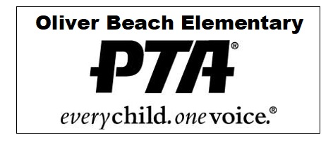

**OLIVER BEACH ELEMENTARY SCHOOL PTA**

**12912 Cunninghill Cove Rd, Baltimore, MD 21220**

[**oliverbeachpta@gmail.com**](mailto:oliverbeachpta@gmail.com) **|** [**www.oliverbeachpta.org**](http://www.oliverbeachpta.org) **|** [**(443) 809-5943**](https://www.google.com/search?client=safari&rls=en&q=oliver+beach+elementary+school&ie=UTF-8&oe=UTF-8)

__________________________________________________________________________________________

Daria Greensfelder - President Morgan Wood- Vice President Caitlin Wood- Treasurer

Jaimie Schorr- Rec. Secretary Kelsie Wagner- Corr. Secretary

__________________________________________________________________________________________

**Oliver Beach Elementary School PTA Disbursement Request**

**School Year 2024-2025**

**To the Treasurer: Caitlin Wood**

Date Submitted: ___________________________________

Pay to the Order of: __________________________________________________

Amount: ________________________

Purpose: _______________________________________________________________________________________

Itemize Expenses Below:

1. ___________________________________________________________________________________

2. ___________________________________________________________________________________

3. ___________________________________________________________________________________

4. ___________________________________________________________________________________

Printed Name of Requestor: _______________________________________________

** PLEASE STAPLE A COPY OF YOUR RECEIPT(S) TO THE BACK OF THIS FORM PRIOR TO FORWARDING TO THE TREASURER. ** -------------------------------------------------------------------------------------------------------------------------------------------------------------------------------

This portion to be completed by Treasurer:

Budget Item: __________________________________________________

Check ___________ PayPal __________ Check Card ____________

Paid by Check No: _____________ Date of Withdrawal: __________________

PayPal Transaction#: ________________ PayPal Transaction Date: __________________

Check Card Transaction#: _______________ Check Card Transaction Date: ______________